2017 PLATEAU Conference Lesson Plan
Presenter Biography:
Chelsea Silva, presenting Human Ecology and the Colorado Watershed, has a B.A. and B.S. from University of Idaho, Moscow, ID in Environmental Sciences and Spanish, and a M.S. in Environmental Sciences and Policy from Northern Arizona University, specializing in human perceptions on land use change and ecosystem services in Latin America. Chelsea has over five years teaching experience from pre-K to graduate level students in Arizona and Idaho. She currently serves as an AmeriCorps VISTA member in Flagstaff, AZ with the City of Flagstaff Sustainability Section and the Friends of the Rio de Flag. Her focus is on capacity building and increasing student interest in STEM careers through outdoor service-learning projects and citizen science. My interest in teaching stems from my love for learning and the excitement that I see if a student that has learned something new. I chose to present on watersheds because they shape us geographically and define us regionally.
Workshop Description:
Title: Mapping Human Ecology and the Colorado Watershed
Presenter: Chelsea Silva
Participants will learn how to explore the socioecological elements of the Colorado Watershed using Google Earth. They will also learn how to build an easily-stored watershed to explore socioecological elements of their local watershed. Additionally, participants will learn about human ecology through a group exercise. Participants will receive lesson plans for the Google Earth and group exercise and instructions for building their watershed. This workshop is designed for 6th-12th, but can be adapted for K-5.

Lesson Plan: Mapping Human Ecology and the Colorado Watershed
- Introduction human ecology as it relates to the Colorado River Watershed
  - Show map of Colorado River Watershed on Page 3 of this 2016 Annual Report for the Colorado River Water Users Association (CRWUA) to introduce the watershed.
  - Human Ecology is an interdisciplinary and transdisciplinary study of the relationship between humans and their natural, social, and built environments.
  - Facts about the Colorado River Watershed:
    - 243,000 square miles in size
    - Spans across 7 states including AZ, CA, CO, NM, NV, UT, WY as well as Mexico
    - 1,450 miles of river from mountains in Colorado to Mexico
    - 40 million people depend on the Colorado River for water supply
    - 22 tribes use and live within this watershed
    - 7 Wildlife Refuges
    - 4 National Recreation Areas
    - 11 National Parks
    - 4,200 Megawatts electricity produced by dams on the Colorado River
  - Show bar graph of “Figure C-4: Historical Colorado River Water Consumptive Use” by sector (agricultural, municipal and industrial, energy, minerals, fish and wildlife recreation, etc.) on Page C-9 of the 2012 “Colorado River Basin Water Supply and Demand Study” from the Bureau of Reclamation
  - Show line graph of “Figure 2: Historical Supply and Use and Projected Future Colorado River Basin Water Supply and Demand” from the Executive Summary for the “Colorado River Basin Water Supply and Demand Study” from the Bureau of Reclamation (see Figure C-8 on Page C-25 of the full report for more details)
  - Colorado River Compact: 1912 agreement to water rights from the Colorado River between seven states: Wikipedia Page

- Use Timelapse from Earth Engine to explore changes in land use and water bodies through time from 1984-2016.
Consider showing students changes in the mouth/delta of the Colorado River as it flows into the Gulf of California/Sea of Cortez (the river no longer reaches the gulf and hasn’t for at least a decade). In 2014, after 16 years the river was able to connect to the sea – check out the story of how this was possible here.
  - Timelapse is a powerful tool, and I recommend using it here to discuss population growth in the Southwest which requires more land, energy, and food. We can correlate these things with effects on the Colorado River whether it be the increase in water demand, increase in recreation, or increase in “indirect” effects on the watershed such as agricultural production, energy production, municipal water use, etc.

- Introduction to Google Earth Labs
Google Earth Labs can be used by you and your students to explore the Earth by topic (climate, drought, fisheries, etc.). Here is the main menu – see the sidebar for selecting different labs by topic. Here is a User Guide for Google Earth to help you as you familiarize yourself with Google Earth.
  - We can explore the Colorado River Watershed under the topic “Droughts” Lab 2B: Explore Your Watershed in Google Earth (Click topic “Drought” “Lab 2 What’s a Watershed?” “Lab 2B Explore Your Watershed in Google Earth”).
    - Follow the directions on the Lab 2B webpage to download Google Earth onto your PC or Mac (see “Start Google Earth on Your Computer” on the Lab 2B webpage)
    - Add watershed data layer to Google Earth (see directions under “Download Outlines of the Watersheds of the United States” [you will be redirected to the USGS to download the .kml file])*
    - Optional: Add US State layer and Archaeology of America layer
      - Follow this link to the US Census Bureau for US state layer (under “Nation-based Files”)
      - Follow this link to click on the “Archaeology of America and Canada” link to download this layer for Google Earth from the Archaeological Institute of America
    - Once your data is downloaded, you can explore elevation, land cover, population, streams, and nearby archaeological sites within the Colorado Watershed.
*Alternatively, you can download a .kml folder (one file type compatible with Google Earth) labelled “Mapping Human Ecology and the Colorado Watershed” from the Friends of the Rio de Flag website here. This file includes the Colorado Watershed USGS file, US State Census Bureau file, and Archaeology of America file.
If you have any questions, do not hesitate to email me, Chelsea Silva, at chelsangelina@gmail.com!
- Limerick/Haiku: Independent Project
This portion of the lesson is split into Part A and B.
  - Part A: Once you’ve introduced watersheds and human ecology, give your students about 10 minutes to take a walk outside. Have them think about their home watershed or the larger Colorado Watershed. While they are walking outside, have them make a list of nouns, adjectives, and verbs they would use to talk about the watershed and human ecology. Make sure you let the students know that this is intended to be an independent assignment (otherwise, they might end up spending ten minutes chatting instead of making observations ).
  - Part B: Have the students set their list of words aside and we will come back to them after building our watershed models (see Part 5 below). Once their models are complete, introduce limericks and haikus (you can use any type of poem format here – I’ve chosen these two formats for their simplicity and ease of writing; you might also choose free verse). Explain how each type of poem should be set up (e.g., number of syllables) and show them an example (use the ones below if you like). Close the class period by having students share their poems.
    - HAIKU: This ancient form of poem writing is renowned for its small size as well as the precise punctuation and syllables needed on its three lines. It is of ancient Asian origin. Haiku's are composed of 3 lines, each a phrase. The first line typically has 5 syllables, second line has 7 and the 3rd and last line repeats another 5. In addition, there is a seasonal reference included.

EXAMPLE
It flooded it dried
Rio de Flag came alive
Managers decide

With this example, you could discuss the historical rerouting of the Rio de Flag in the late 1800s and how this has created flooding issues on the Southside.

    - LIMERICK: This five-line poem also follows a syllable count.
Line 1: 7-10 syllables
Line 2: 7-10 syllables
Line 3: 5-7 syllables
Line 4: 5-7 syllables
Line 5: 7-10 syllables

EXAMPLE
Running once was a stream down the Mountain
That the People used back near’ a thousand
It meandered through prairies
And fed many fruit berries
But now faces great threats oh so daunting

With this example, you could discuss the fact that the Northern Sinagua occupied Picture Canyon (along the Rio de Flag) from 700 to 1300 A.D., plus you could discuss any of the following: climate change predicted effects on surface and groundwater in Northern Arizona; potential impacts of future developments (increased stormwater runoff leading to increased flooding issues); implications of Army Corps of Engineers Rio de Flag Flood Control Project (Rio set to be undergounded from Frances Short Pond to City Hall with a small composite channel aboveground where water will flow only sometimes [seasonal flows would no longer be visible, e.g. big flows from monsoons and winter storms])

- Building a Watershed Model
During this portion of the lesson, students will build watershed models out of salt dough using a topographic map of the local topography.

Table 1: Supplies needed for Watershed Models

SUPPLY | INSTRUCTIONS FOR SUPPLY
Salt Dough Recipe | See recipe below. One recipe makes enough for ~3 watershed models, i.e., you will need to times the recipe by 5 to make 15 models, etc.
Cardboard “landscapes” | Each student needs a landscape. Cut out rectangular landscapes (roughly 6” x 12”) out of old, thick cardboard box. Poke holes in the area where the salt dough will be placed to make sure the dough can be “secured” to the landscape as it dries.
Paint | Outdoor Paint or Acrylic works well.
Paintbrushes | One for each student.
Topographic Maps | One for each student or one map projected that can be used by the entire class.

  - FIRST, you will need to make the salt dough. You can make it beforehand or have the students make it during class. Either way, make sure you refrigerate it (up to 2 or 3 days ahead of time) if you do not use it right away. Below is the recipe, obtained online:

Recipe for Homemade Air Dry Salt Dough

By Chris Dunmire

Salt Dough Recipe

Ingredients:

2 cups all-purpose flour
1 cup salt
1 cup cold water

Directions: In a large bowl, mix table salt and flour together. Gradually add 1/2 cup of water and mix to desired consistency. Knead the dough on a flat surface, adding a few more drops of water as needed (but not making it too moist).

Once the dough is made, you can divide it up into small portions to roll into 1/8" thick pieces with a rolling pin. Use cookie cutters to cut out a variety of shapes, and place the shapes on wax paper or other surface to dry. If you want to make hanging ornaments, pierce the dough through with a toothpick while it's wet.

Allow the shapes to dry for a day or two, turning them over periodically to speed up the drying process. You may need to re-pierce the hole several times during the drying process. After the shapes dry, you can use a fine grit sandpaper to gently smooth any rough edges.

Baking Alternative
Instead of allowing the dough shapes to air dry, you can bake them in the oven at 200 degrees F until hard. Baking times varies depending on oven and dough thickness. Make sure the dough is completely baked. You can cover the dough with aluminum foil if it starts to darken before completely baked through.

Salt Dough Project Suggestions and Tips:
- You can store prepared salt dough in a sealed container in the refrigerator for a day or two before using.
- Add color to the dough by mixing food coloring or paint into the water before adding it to the flour/salt mix. Alternatively, you can paint the finished baked dough with acrylic paint.
- Painted objects should be sealed on all sides with polyurethane spray or clear varnish to make them lasting gifts or keepsakes.

  - SECOND, prep the cardboard “landscapes”. Make these at least 6” x 12” and cut from old, thick cardboard boxes (thicker boxes are better for a more stable landscape). The simplest landscapes can be rectangular in shape, but you can get creative and make different shapes from which the students can choose. Make sure the cut-out is large enough to include some text (e.g., a legend for the map, the student’s poem, facts about the watershed, etc.). Poke holes in the landscape where the dough will be placed to help the model stay put as it dries (make sure students force the dough into the poked holes when they are making the models to aide in this process).
  - THIRD, print topographic maps for each student. Appendix A is a topographic map of the San Francisco Peaks. You can find other topographic maps by typing the name of your geographic point (e.g., “Monument Valley”) and “topographic map” into any search engine. You can also simply project the image of your topographic map onto a screen for the entire class to use at the same time.
  - FOURTH, make your watershed models! You can use the models to discuss: understanding elevation on a topographic map; gravity; human influences on our watershed; how a landscape develops (e.g., San Francisco Peaks once a giant volcano and also carved by glaciers [plus the cinder cones around the peaks]); life zones
    - Have students use their topographic maps to make the model
    - They can then paint the model. Here, you can have students paint creatively, e.g., general colours of the mountain, or they might pain the different life zones (see Appendix B).
  - FIFTH, let the models dry for 1-2 days before having the students take them home
  - OPTIONAL: You might also choose to substitute these salt dough models with a group activity such as that outlined in Part A of the Google Earth Labs:
    - Drought, Lab 2A: Make a Watershed Model
  - See Appendix C for examples

- Close with poems and share
Once the students have completed their models, take the time to have them write up their poems as per Part 4B of this lesson. The students can then share their poems with the class. They can also glue/rewrite these poems to be included as part of their watershed salt dough model.

APPENDIX A: Topographic Map of the San Francisco Peaks
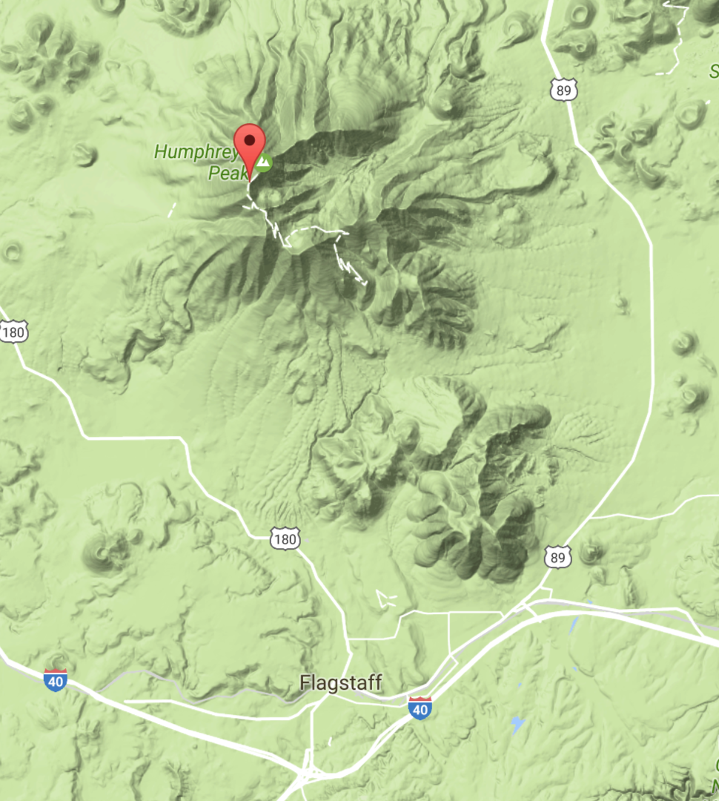

APPENDIX B: Life Zones of the San Francisco Peaks
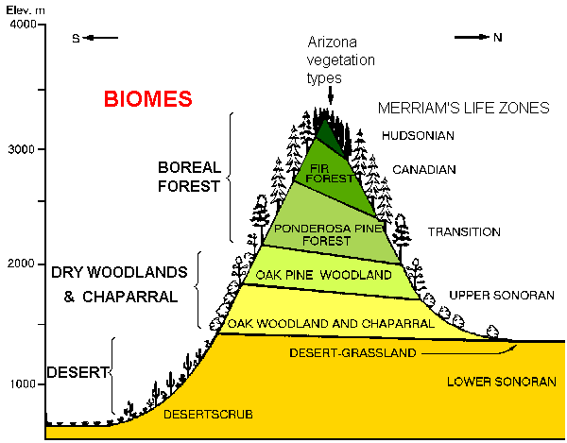
Graph Source: http://www.geo.arizona.edu/Antevs/biomes/azlifzon.html
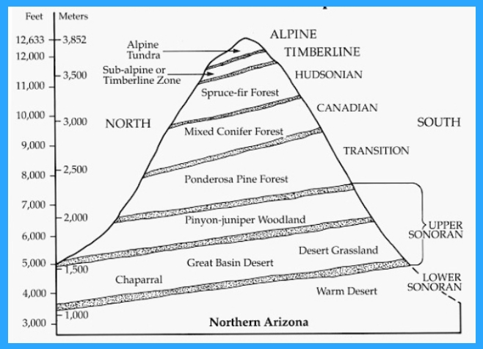
Graph Source: http://written-in-stone-seen-through-my-lens.blogspot.com/2012/10/hiking-mount-humphreys-of-san-francisco.html
Table 2: Additional Life Zone Information
ELEVATION RANGE (FT) | VEGETATION TYPE | LIFE ZONE
11,500-12,700 | Alpine Tundra | Alpine
11,000-12,000 | Sub-Alpine or Timberline Zone | Timberline
9,500-11,500 | Spruce-Fir Forest | Hudsonian
8,000-9,500 | Mixed Conifer Forest | Canadian
6,000-8,500 | Ponderosa Pine Forest | Transition
3,500-6,500 | Pinyon-Juniper Forest | Upper Sonoran
3,500-6,500 | Chaparral/Great Basin Desert/Desert Grassland | Upper Sonoran
100-3,500 | Warm Desert | Lower Sonoran

FACTS ABOUT EACH LIFE ZONE:
LIFE ZONE | FACTS
Alpine | This life zone is equivalent to the tundra found in extreme northern latitudes. The mean-max temperature is only 66-77 degrees F. Rainfall is from 44-60 inches with much falling as snow. Characteristic plant species include grass, sedges, moss, lichens, willow and flowering perennial plants. The lone common mammal species is the marmot, a large western woodchuck. Birds are common during the day but usually fly below tree line at night. This is an uncommon life zone in Arizona. It can be found on Mt. Baldy in the White Mountains, and on the San Francisco Peaks north of Flagstaff. Large areas of this zone may be seen in Southwestern Colorado.
Timberline | See above description.
Hudsonian | This life zone is roughly equivalent to spruce-alpine fir forests. It occurs at elevations of 9,000-11,000 feet. Precipitation averages 30-35 inches annually. It occurs at appropriate elevations on San Francisco Forest, White Mountains, Chiricahua Mountains, and the Graham Mountains. Other plants include the Englemens Spruce. Animals are the same as the Canadian life zone. Mean-max temp: 70-82 degrees F.
Canadian | This life zone is roughly equivalent to Douglas fir forest. Elevation of this life zone is from 8,000-9,500 feet. Precipitation is from 25-30inches annually. Other trees characteristic of this life zone include white fir and quaking aspen. This life zone is found at approximate elevations on the mountains of Arizona. Characteristic animals: elk, deer, and bear. Mean-max temp: 75-85 degrees F.
Transition | Flagstaff (6,900 ft); Rainfall varies from 19-25 inches annually. This life zone covers much of the Kaibab Plateau, the area above the Mogollon Rim, and the appropriate elevations in the following mountain ranges: Pinal, Gila, Pinalenos, Galiuros, Santa Catalina’s, Santa Rita’s, Huachuca’s, and the Chiracahuas. Few different species of plants are found in this zone including oak, grass, and Indian paintbrush. Characteristic animals: deer’s, mountain lion, and Steller’s jay. Mean-max temp: 86-90 degrees F.
Upper Sonoran | See description below.
Upper Sonoran | This life zone includes woodland, chaparral, grassland, and Great Basin Desert vegetation. The southernmost part of the Great Basin Desert lies in Northern Arizona, mainly north and east of Flagstaff as well as in the northwestern part of the state in the Arizona Strip country. Rainfall varies from 12-20 inches. Characteristic plants: include Pinyon, juniper, oak, manzanita, and sagebrush. Characteristic animals: coyote, ground squirrel, javalina, and deer, rabbit. Mean-max temp. 90-100 degrees F.
Lower Sonoran | This life zone is roughly equivalent to desert. Three different deserts are represented in Arizona. They are the Sonoran, Chihuahuan, and Mohave deserts. Annual precipitation varies from 3-11 inches, increasing in amount from west to east.  Characteristic plants include: Palo Verde, cholla, saguaro, yucca, mesquite, and ocotillo. Characteristic animals: scorpion, reptiles, coyote, quail, hawk, and tarantula, rabbit. Mean-Max. Temp. 100-110 degrees F.
“Facts” obtained from: http://www.mpsaz.org/rmhs/staff/aeullman/class1/biologycalendar/files/life_zones_of_arizona.pdf

Appendix C: Salt Dough Watershed Model Examples
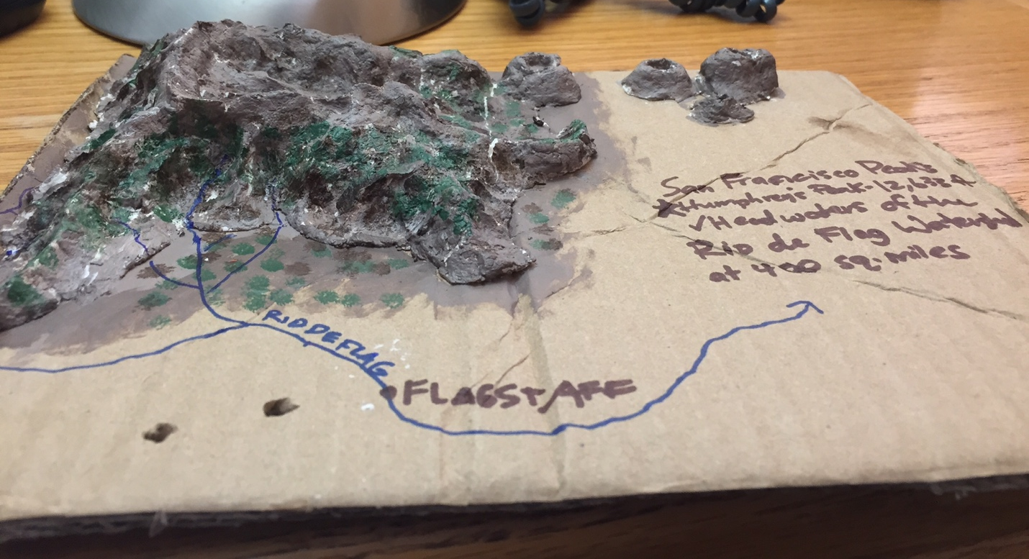
Above: Vegetation on peaks with Rio de Flag flowing through Flagstaff; facts about the watershed on right.
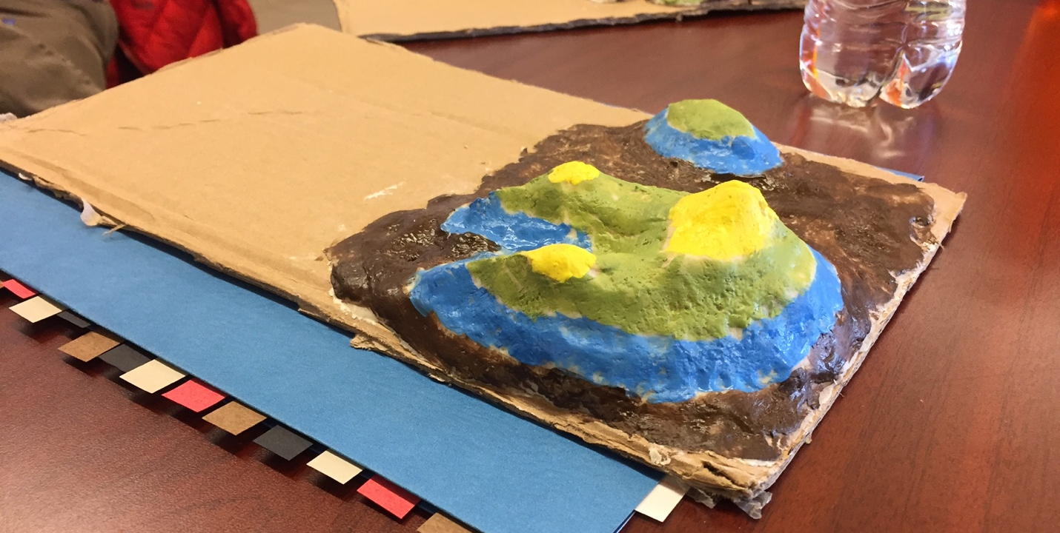
Above: Life zones drawn on salt dough watershed model.

