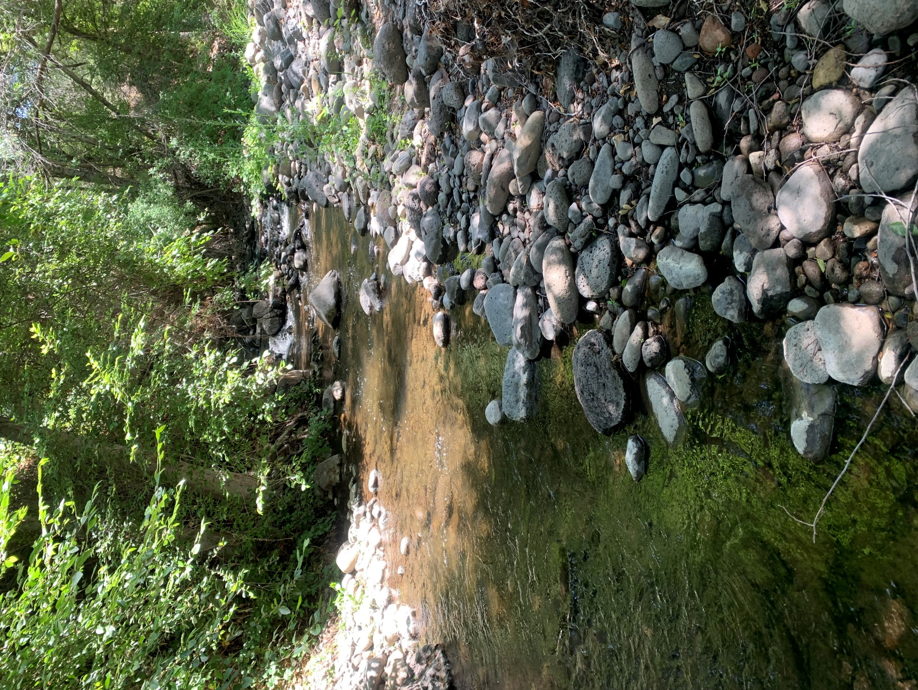

**The Sustainable Water Network: A Coalition for River and Watershed Health.**

**November 3rd. @ 6 pm**

Kristen Wolfe

Sustainable Water Workgroup, Coordinator